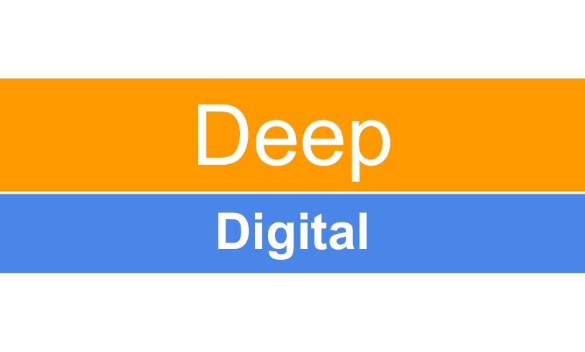

Let us build an amazing website for your business . We provide services for both Static and Dynamic Websites from One page simple website to complex E-Commerce application .

Tell us your requirements and get live website in 7 days .

Our Services -

* Web Designing
* Web Development
* Website Maintenance
* SEO Services

Price Details -

| **Static Websites** | **Dynamic Websites** | **Complex Dynamic Websites** |
| --- | --- | --- |
| Any Static Website including-   * Max 25 Pages * Domain * Hosting * Consulting Service | Any Dynamic Website including -   * Max 25 Pages * Domain * Hosting * Database Services * Consulting Service | Any Complex Dynamic Websites include -   * Domain * Hosting * Database Services * Payment Gateway Integration * Consulting Service |
| Rs 4999 | Rs 9999 | Rs 14999 |

* Renewable charges of Rs 1000 Annually .

Contact for further details -

Deep Digital Services

+91 8107586990

[contact.deepdigital@gmail.com](mailto:contact.deepdigital@gmail.com)